NUTRITION ASSISTANT APP
Prepared in partial fulfillment of [Mern Stack]
At
APSCHE Short-Term Virtual Internship Program.
Under the guidance of
SmartBridge
Submitted by
Meripe Akshaya
Takwana Daniel Mukushwa
Musini Veera Venkata Anantha Pavani
Nori Bhavika
ACKNOWLEDGEMENT
I would like to express my heartfelt gratitude to all those who have contributed to the successful completion of the Nutrition Assistant App project. This opportunity has been an enriching and rewarding experience, and I am truly thankful for the support, guidance, and encouragement I have received along the way.
I extend my sincere regards to [Guide Name], my supervisor and mentor, for providing valuable insights, constant guidance, and unwavering support throughout the duration of this project. Their expertise and encouragement have been instrumental in shaping the direction of this work.
I would also like to thank the entire team at [Institution Name] for fostering a collaborative and innovative environment. The knowledge sharing and feedback I received from my colleagues significantly contributed to the development and success of this project.
In conclusion, I am grateful to have had the opportunity to work on this project, and I look forward to leveraging the skills and knowledge gained to contribute positively to future endeavours.
Thank You,
Sincerely,
Meripe Akshaya
Takwana Daniel Mukushwa
Musini Veera Venkata Anantha Pavani
Nori Bhavika
ABSTRACT
The “Nutrition Assistant App” is a full-stack wellness management system designed to help users and dietitians create, manage, and track personalized nutrition plans through an interactive interface. Maintaining a balanced diet is challenging in today's fast-paced world, and this application simplifies the process by offering personalized nutritional guidance, meal planning, dietary tracking, and access to educational resources.
The application is built using the MERN stack — MongoDB, Express.js, React.js, and Node.js — with a responsive React frontend styled using Bootstrap or Material UI, and a RESTful Express.js backend. Nutrition and meal data are persisted in MongoDB, and full CRUD (Create, Read, Update, Delete) operations are supported across client profiles, meal plans, and progress records. Role-based dashboards present key metrics such as calorie and nutrient intake, adherence to nutritional goals, and progress over time, giving both users and dietitians an at-a-glance view of nutritional health.
The project follows a modular structure with separate directories for routes, controllers, models, views, and configuration, making the codebase maintainable and easy to extend. Role-based access control implemented using JWT (JSON Web Tokens) and bcrypt-based password encryption ensures secure access for users, dietitians, and administrators. Version control is maintained using Git, with the source code hosted on GitHub.
This report documents the complete lifecycle of the project, including the methodology adopted, the system design and architecture, the implementation details for each module, the results obtained, and the conclusions drawn, along with directions for future enhancement. While the application offers valuable support for managing weight, enhancing athletic performance, and accommodating dietary restrictions, it is designed to complement — not replace — professional medical or dietary advice.
TABLE OF CONTENTS
1. Introduction 1
2. Methodology 4
3. System Design 8
4. Implementation 12
5. Results 17
6. Conclusion 19
1. INTRODUCTION
1.1 Background
Maintaining a balanced diet is one of the most valuable contributors to long-term health, offering direct benefits to weight management, disease prevention, and overall wellbeing. As lifestyles become busier, tracking what is eaten, understanding nutrient composition, and sticking to dietary goals becomes increasingly difficult without a structured tool. Digital nutrition assistants, powered by extensive food databases and data-driven insights, offer a way to log meals, monitor nutrient intake, and receive personalized recommendations, allowing individuals to make informed lifestyle choices quickly and consistently.
1.2 Problem Statement
Individuals and dietitians often lack a simple, centralized system to plan meals, track nutritional intake, and monitor progress toward health goals without relying on scattered spreadsheets or expensive third-party subscriptions. There is a need for a lightweight, self-hosted web application that allows users to log meals and track nutrients, while enabling dietitians and administrators to manage client profiles, meal plans, and progress through an intuitive dashboard.
1.3 Objectives
- To design and develop a full-stack web application for personalized nutrition management.
- To integrate meal planning and dietary tracking with calorie and nutrient monitoring.
- To provide dashboards summarizing nutrient intake, goal adherence, and progress history.
- To implement complete CRUD functionality for client profiles, meal plans, and progress records.
- To design a clean, responsive, and user-friendly interface.
- To implement secure, role-based access for users, dietitians, and administrators.
- To structure the codebase in a modular and maintainable way.
- To version-control the project using Git and host it on GitHub.
1.4 Scope of the Project
The scope of this project covers the design, development, and deployment preparation of a web-based nutrition management system. It includes user registration and login, client profile management, meal plan creation and tracking, nutrient analysis and progress monitoring, and an admin dashboard for role management and platform oversight. The scope also extends to recipe suggestions, grocery assistance, and interactive features for connecting with nutrition professionals, though the application is intended to complement — not replace — professional medical or dietary advice.
1.5 Organization of the Report
This report is organized into six chapters. Chapter 2 discusses the methodology and technology stack adopted for the project. Chapter 3 presents the system design, covering the overall design approach, data design, use cases, and interface design considerations. Chapter 4 details the implementation, including the project file structure and an explanation of how each module of the application was built. Chapter 5 presents the results and testing outcomes obtained from the completed application. Chapter 6 concludes the report and outlines directions for future work.
1.6 Significance of the Project
Beyond its immediate functionality, this project served as a practical exercise in building a complete, production-oriented wellness web application from the ground up. It required working across the full stack — from designing a data model that links users, clients, meal plans, and progress records, to writing server-side business logic, to building a responsive and data-driven user interface, to implementing secure, role-based authentication. This end-to-end exposure mirrors the kind of work expected in real-world software development roles, where a developer is responsible not just for writing application code but also for how nutritional data is validated, secured, and presented meaningfully to end users.
1.7 Existing Systems and Motivation
Several commercial platforms already offer meal tracking and nutrition management capabilities, ranging from dedicated calorie-counting apps to full clinical dietetics suites. While these platforms are powerful, they are often designed for large organizations, come with recurring subscription costs, and require integration effort that may not be justified for a smaller practice, a student project, or an internal tool. Many of them also operate as closed, third-party services, meaning nutritional and health data is stored outside the organization's own infrastructure, which can raise concerns around data ownership and privacy.
This project was motivated by the gap between these heavyweight commercial solutions and the simpler needs of an individual, a small dietetics practice, or a student project. By building a self-hosted application with a well-understood MERN technology stack, nutrition and progress data remains entirely under the owner's control, the system can be modified freely to fit specific needs, and there are no ongoing licensing costs. The trade-off is that certain advanced features — such as clinical-grade nutrient databases — are necessarily simpler than what a large commercial platform might offer, but as demonstrated in Chapter 5, this trade-off is reasonable for the scale the application is intended to handle.
2. METHODOLOGY
2.1 Development Approach
The project was developed using an iterative and incremental approach inspired by Agile principles. The application was broken down into functional modules — user authentication, client profile management, meal planning, nutrient tracking, and the admin dashboard — each of which was designed, implemented, and tested independently before integration. This approach allowed early identification of issues and continuous refinement of the user interface and backend logic.
Work was carried out in short, focused cycles. Each cycle began with identifying a single piece of functionality, followed by building the minimum backend logic needed to support it, connecting that logic to a simple view, and then testing it manually before moving on to the next piece. This kept the codebase in a working state at almost every stage of development, rather than leaving large parts of the application unfinished until the very end. It also made it easier to catch design mistakes early — for example, deciding how progress should be recalculated after a meal plan update was resolved while building the tracking module, rather than being discovered later during testing.
2.2 Requirement Analysis
Before development began, the requirements of the system were separated into functional and non-functional categories. This helped clarify not only what the application needed to do, but also the quality standards it needed to meet.
Functional requirements included: allowing a user to register and log in securely; allowing a client profile to be created and linked to nutritional goals; enabling meal plans to be created, edited, and tracked against calorie and nutrient targets; presenting a dashboard summarizing nutrient intake and progress history; and allowing dietitians and administrators to manage clients, meal plans, and platform roles.
Non-functional requirements included: the interface should remain usable and readable on both desktop and mobile screen sizes; nutrient calculations should update instantly, with no perceptible delay to the user; the codebase should be organized in a way that a new developer could understand and extend it without difficulty; and access to administrative and dietitian-only functions should be enforced consistently and securely across every backend endpoint.
2.3 Technology Stack
Layer | Technology Used | Purpose
Frontend | React.js, HTML, CSS, Material UI | Building a dynamic, responsive user interface
Backend | Node.js, Express.js | Server-side logic and RESTful API routing
Database | MongoDB | Persistent storage of users, clients, meal plans, and progress data
Authentication | JWT, bcrypt | Secure, role-based authentication and password encryption
HTTP Client | Axios | Communication between the React frontend and Express backend
Version Control | Git, GitHub | Source code management and collaboration
API Testing | Postman | Testing and validating REST API endpoints
2.4 Justification of Technology Choices
Node.js and Express.js were chosen for the backend because of their lightweight, non-blocking architecture, which is well suited to an application that needs to handle many short-lived requests, such as meal-plan submissions and dashboard queries, without the overhead of a heavier framework. Express in particular offers a minimal, unopinionated routing layer that made it straightforward to keep routes, controllers, and models cleanly separated.
React.js was selected for the frontend because its component-based architecture made it easy to build reusable dashboard widgets, meal-planning forms, and progress charts, while keeping the interface responsive to real-time changes in nutrient data. Since the application's interface includes multiple interactive dashboards, a component-driven framework was judged to be a better fit than server-rendered templating for this use case.
MongoDB was chosen over a relational alternative because nutrition and meal-plan data is naturally document-oriented — a single meal plan can contain a variable number of meals, each with a variable number of nutrient fields — and MongoDB's flexible schema accommodates this variability without requiring complex joins. A NoSQL document store also made it straightforward to evolve the data model as new nutrition-tracking features were added during development.
JWT-based authentication combined with bcrypt password hashing was chosen because it requires no server-side session storage, scales cleanly across multiple backend instances, and is a well-established, secure pattern for enforcing role-based access control across users, dietitians, and administrators.
2.5 Development Tools
- Visual Studio Code — source code editor
- Node Package Manager (npm) — dependency management
- MongoDB Atlas / MongoDB Compass — database design and querying
- Postman — API testing
- Git & GitHub — version control and repository hosting
- Google Chrome / Firefox DevTools — UI testing and debugging
2.6 Testing Methodology
Testing was carried out continuously alongside development rather than as a separate phase at the end of the project. Each backend route was tested in isolation using Postman before its corresponding frontend view was built, which made it possible to confirm that the correct data was being returned and that nutrient calculations were behaving as expected before any UI code was written. Once views were connected, manual end-to-end testing was performed by using the application as a real user would — registering, creating a client profile, building a meal plan, logging progress, and reviewing the dashboard. Edge cases such as incomplete meal-plan submissions, unauthorized access attempts to dietitian-only routes, and boundary values for calorie and nutrient targets were also tested to confirm that the application handled them gracefully.
2.7 Development Life Cycle
The project followed these stages: requirement analysis, system design (design approach and data design), implementation of backend routes and frontend views, integration of role-based authentication, testing of CRUD operations and nutrient-tracking accuracy, and finally preparation of the deployment configuration. Each stage fed directly into the next, with lessons learned during implementation and testing occasionally looping back to refine the original design decisions — consistent with the iterative philosophy described at the start of this chapter.
3. SYSTEM DESIGN
3.1 Design Approach
The application follows a Model-View-Controller (MVC) inspired design, which is the natural pattern for Express.js applications paired with a React frontend. In this design, incoming requests from the browser are first received by the routing layer, which determines which piece of business logic should handle the request. The business logic itself lives in the controller layer, where tasks such as validating input, computing nutrient totals, and reading from or writing to the database take place. Once the controller has gathered or updated the necessary data, it returns a JSON response that the React frontend consumes and renders — keeping presentation entirely separate from business logic.
This separation also made the project easier to build incrementally. The routing and controller logic could be developed and tested using Postman before any of the React views existed, and the views could later be refined for appearance and responsiveness without needing to touch the underlying business logic or database queries.
3.2 Data Design
The application's data design is centered around four core collections: Users, Clients, MealPlans, and Progress. The Users collection stores authentication credentials and role information (user, dietitian, or administrator). The Clients collection stores profile information and nutritional goals, linked to a specific user through a unique identifier. Each entry in the MealPlans collection links to a specific client and contains the meals, foods, and computed nutrient totals for a given plan. The Progress collection maps users to their nutritional goals and adherence history over time, allowing trends to be tracked across multiple meal plans.
Data integrity is maintained at the application layer: nutrient totals are always recalculated whenever a meal plan is created or edited, so the stored values are guaranteed to always correspond to the current contents of the plan rather than becoming stale or inconsistent.
3.3 Use Case Design
The system supports three broad categories of users: users who log meals and track progress, dietitians who create and manage meal plans for their clients, and administrators who oversee platform roles and data. The key interactions between these users and the system are summarized below.
- User registers and logs in to the platform.
- User or dietitian creates a client profile with nutritional goals.
- Dietitian creates and assigns a meal plan to a client.
- System computes calorie and nutrient totals for each meal plan.
- User logs meals and progress against their nutritional goals.
- Administrator manages user roles and reviews platform-wide analytics.
Each of these interactions maps directly onto a route and controller function within the application, keeping the relationship between the use cases and the implementation straightforward to trace.
3.4 UI Design Considerations
The interface was designed to be minimal, responsive, and accessible on both desktop and mobile devices using Bootstrap's grid system and responsive utility classes. A card-based layout is used for dashboard statistics, and clearly labeled forms are used for meal-plan creation and client profile management, with charts and progress bars used to visually communicate calorie and nutrient distribution.
Consistent spacing, a restrained colour palette, and clear typography were prioritized throughout so that both the meal-planning forms and the nutrient dashboards remain easy to scan at a glance, even as the number of tracked meal plans and progress entries grows over time.
3.5 Design Considerations for Reliability
A few additional design considerations were factored in to keep the application dependable in everyday use. Server-side validation ensures that a meal plan or client profile cannot be saved without the required nutritional fields, reducing the chance of incomplete or meaningless records reaching the database. Centralized error-handling middleware in Express ensures that a failure — such as a temporary loss of database connectivity — results in a clear response rather than the application crashing silently. Role-based middleware guards every dietitian- and administrator-only route, preventing unauthorized access even if a request is crafted directly against the API.
3.6 Assumptions and Constraints
The design of the system rests on a small number of assumptions. It is assumed that food and nutrient data will be sourced from a reasonably comprehensive food database, and that users will primarily log pre-defined foods rather than requiring a fully custom ingredient-authoring workflow. It is also assumed that meal-plan volumes will remain at a scale that a single MongoDB instance and a single application server can comfortably handle, rather than the extremely high-throughput volumes that would require a distributed data store.
A number of constraints were also accepted as reasonable trade-offs for the scope of this project. The application does not currently integrate with wearable devices or third-party health platforms; this was considered acceptable for a project-scale deployment but would need to be addressed before broader clinical use. Similarly, nutrient analysis relies on a static food database rather than a continuously updated clinical-grade dataset, which means it can occasionally lack highly specialized or regional foods. These constraints are revisited in Chapter 6 as part of the discussion of future scope.
4. IMPLEMENTATION
4.1 Project File Structure
The project is organized into clearly separated directories so that each concern of the application — routing, business logic, data access, presentation, and static assets — is kept independent and easy to maintain. At the top level, the backend contains a configuration folder for database connection and environment settings, a controllers folder that holds the business logic for handling users, clients, meal plans, and progress, a routes folder that maps incoming URLs to the appropriate controller functions, a models folder containing the Mongoose schema definitions, and a middleware folder containing authentication and role-checking logic. The React frontend is organized into components, pages, and services folders, with a dedicated services layer wrapping all Axios calls to the backend API.
4.2 Backend Implementation
The backend was built using Node.js with the Express.js framework. The main server file initializes the Express application, configures JSON body parsing and CORS, registers the API routes, and connects to MongoDB using Mongoose. It also loads environment variables such as the port number, database connection string, and JWT secret from a dedicated configuration file, keeping sensitive information out of the source code.
The routing layer defines the application's endpoints: routes for user registration and login, routes for creating and managing client profiles, routes for creating, updating, and tracking meal plans, and routes for logging and retrieving progress records. Each route simply delegates the actual work to a corresponding function in the controller layer, keeping the routing definitions short and readable.
4.3 Nutrient Analysis and Meal Planning Module
Nutrient analysis is handled by a dedicated utility module that computes calorie and macronutrient totals for a meal plan by summing the nutritional values of each logged food item against the extensive food database. The module takes the list of foods in a meal plan as input, calculates total calories, protein, carbohydrates, and fat, and compares these totals against the client's nutritional goals to produce an adherence summary. This module is reused both when a new meal plan is created and when an existing plan is edited, ensuring that nutrient totals always reflect the current contents of the plan.
4.4 Database Layer
The MongoDB database consists of four primary collections: Users, Clients, MealPlans, and Progress. The Users collection stores hashed credentials and role information. The Clients collection stores profile details and nutritional goals, referencing the associated user by ID. The MealPlans collection stores the foods, portions, and computed nutrient totals for each plan, referencing the associated client by ID. The Progress collection stores periodic snapshots of adherence and goal tracking, referencing both the user and relevant meal plans. This schema is intentionally kept document-oriented, since the application's primary purpose is to capture flexible, variable-length nutrition data rather than rigidly normalized relational records.
4.5 Frontend Implementation
The frontend is built using React.js, with React Router managing navigation between the login, dashboard, meal-planning, and admin pages. A shared navigation bar and layout component are included on every authenticated page, providing consistent access to the meal-planning form, progress dashboard, and admin panel depending on the logged-in user's role. The dashboard page displays summary statistics — total calorie intake, nutrient breakdown, and goal adherence — as a row of cards, followed by charts visualizing progress over time and a table listing recent meal plans with inline edit and delete actions.
Styling is handled through Bootstrap combined with custom CSS that defines the overall layout, colour scheme, card and chart styling, and responsive behaviour so that the interface adapts cleanly to smaller screens. Axios is used throughout the frontend to communicate with the backend API, with a centralized service layer handling authentication tokens and error responses consistently.
4.6 Role-Based Security Implementation
JWT (JSON Web Tokens) are issued upon successful login and are required for all subsequent authenticated requests. Passwords are hashed using bcrypt before being stored, ensuring that plain-text credentials are never persisted. Express middleware verifies the JWT on every protected route and checks the user's role — user, dietitian, or administrator — before allowing access to role-restricted functionality, such as managing dietitian approvals or viewing platform-wide analytics. This ensures that administrative functions remain accessible only to authorized roles throughout the user journey.
4.7 Git and GitHub Setup
The project was version-controlled using Git from the outset. A local Git repository was initialized in the project folder, all project files were staged and committed with descriptive commit messages, and the repository was then linked to a remote repository on GitHub and pushed to the main branch. This provides a complete history of changes and a central location from which the project can be cloned, reviewed, or deployed.
4.8 Challenges Faced During Implementation
A few practical challenges came up during implementation. Ensuring that nutrient totals always stayed consistent with a meal plan's contents was one of them: since editing a meal plan changes its foods and portions, nutrient totals had to be recalculated on every update rather than simply being copied over from the original submission, otherwise the dashboard's adherence figures could silently drift out of sync with the actual plan. This was resolved by routing both the create and update operations through the same nutrient-analysis utility, so there was only one place in the codebase responsible for producing nutrient totals.
Another challenge was keeping the dashboard's statistics accurate and performant as the number of stored meal plans and progress records grows. Rather than loading every record into the frontend and computing totals in JavaScript, aggregation was pushed down into MongoDB using its aggregation pipeline, which scales far better and keeps the dashboard responsive even as user history grows large.
Finally, implementing role-based access required care to ensure that every dietitian- and administrator-only route was consistently protected. This was addressed by centralizing all role-checking logic into a single reusable middleware function, so there was only one place in the codebase responsible for enforcing access control, reducing the risk of an unprotected route being introduced by accident.

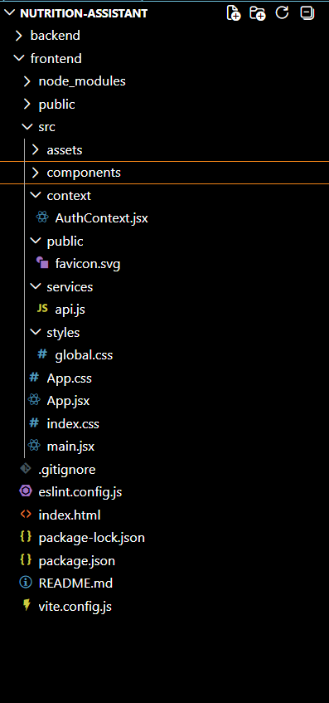
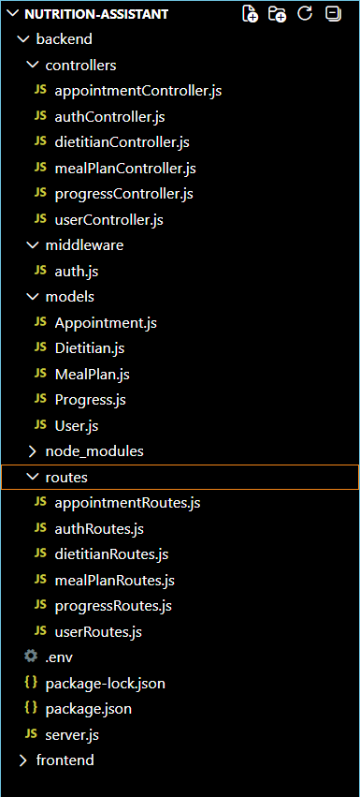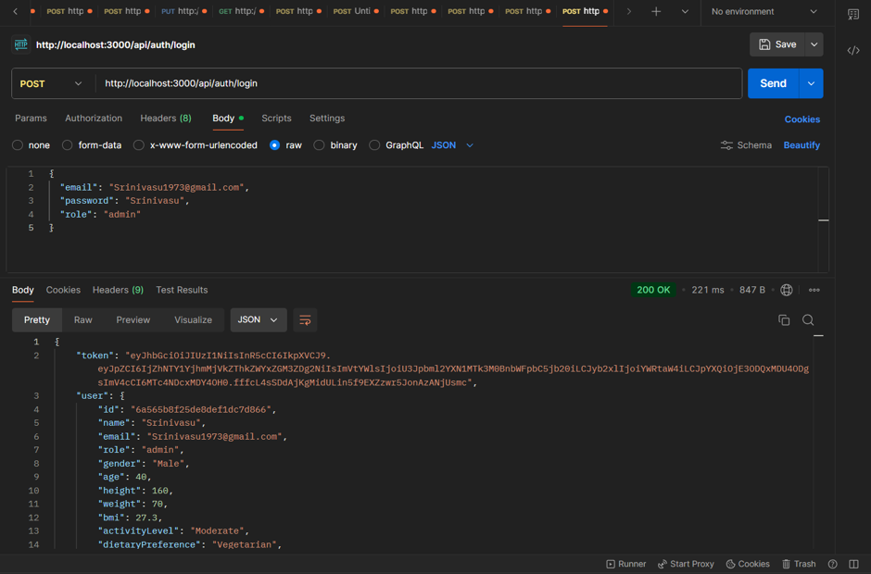
5. RESULTS
5.1 Functional Outcomes
The application was successfully developed and tested locally. Users are able to register, log in, create client profiles, and build meal plans through the interface, with each plan automatically evaluated against calorie and nutrient goals in real time. The dashboard correctly reflects total nutrient intake, an accurate breakdown of macronutrients, and recent progress history. CRUD operations were verified across all core modules: client profiles, meal plans, and progress records can be created, viewed, edited, and deleted successfully.
5.2 Nutrient Tracking and Recommendation Behaviour
The nutrient-analysis module was tested against a range of sample meal plans covering high-calorie, low-calorie, and balanced macronutrient distributions. Meal plans exceeding a client's calorie goal were consistently flagged as over target, while plans falling short of protein or other nutrient goals were consistently flagged as under target. Balanced meal plans that matched a client's nutritional goals were correctly marked as on track. This confirmed that the aggregation-based calculation approach was reliable enough for everyday nutrition tracking.
5.3 Testing Outcomes
Each core feature of the application was manually tested. Submitting the meal-planning form correctly inserted a new record into the database with the appropriate nutrient totals attached. The dashboard's summary cards updated correctly to reflect the number of records and the underlying distribution of nutrient adherence. Editing an existing meal plan updated both its contents and its nutrient totals, since totals are recalculated whenever the plan changes. Deleting a meal plan removed it from both the database and the dashboard's recent activity list. The responsive layout was also verified by resizing the browser window and viewing the application on a mobile-sized viewport, confirming that the navigation, statistic cards, and charts adapted correctly to smaller screens. Role-based access was verified by attempting to reach dietitian- and administrator-only routes as a regular user, confirming that unauthorized requests were correctly rejected. All of these checks passed without issues.

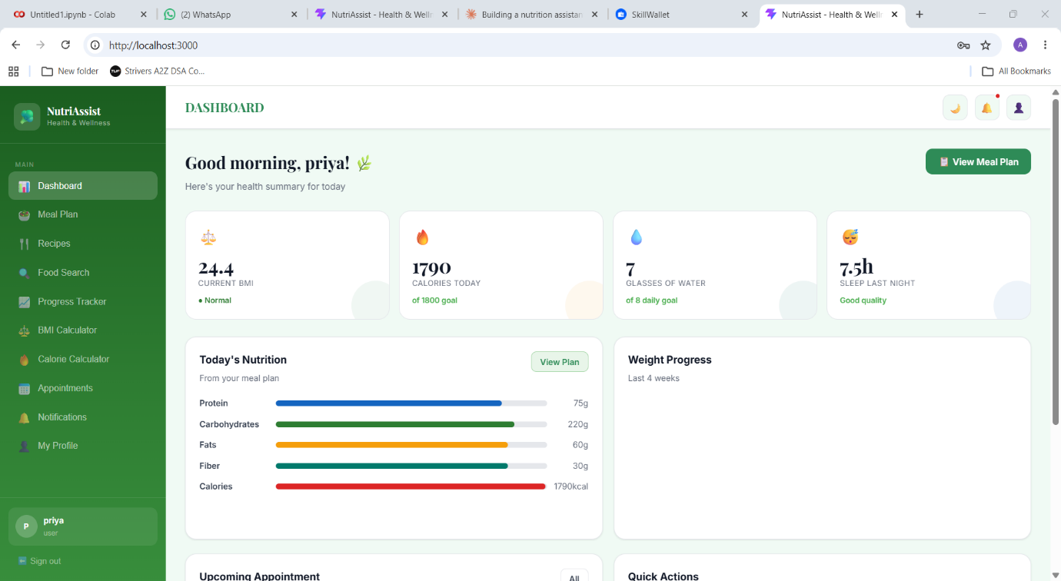

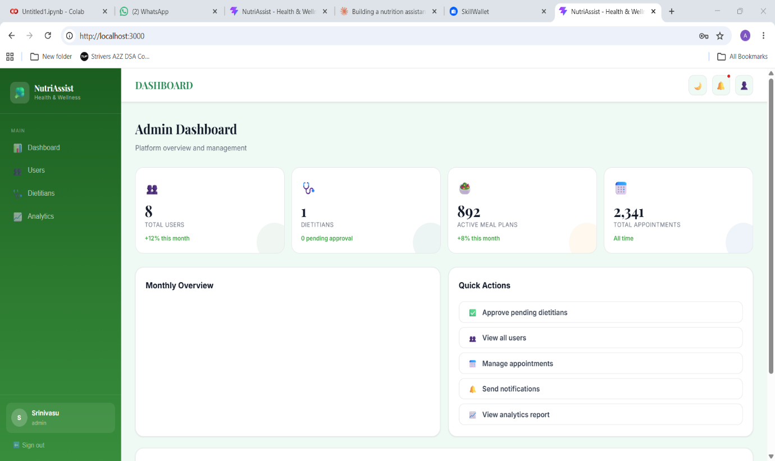

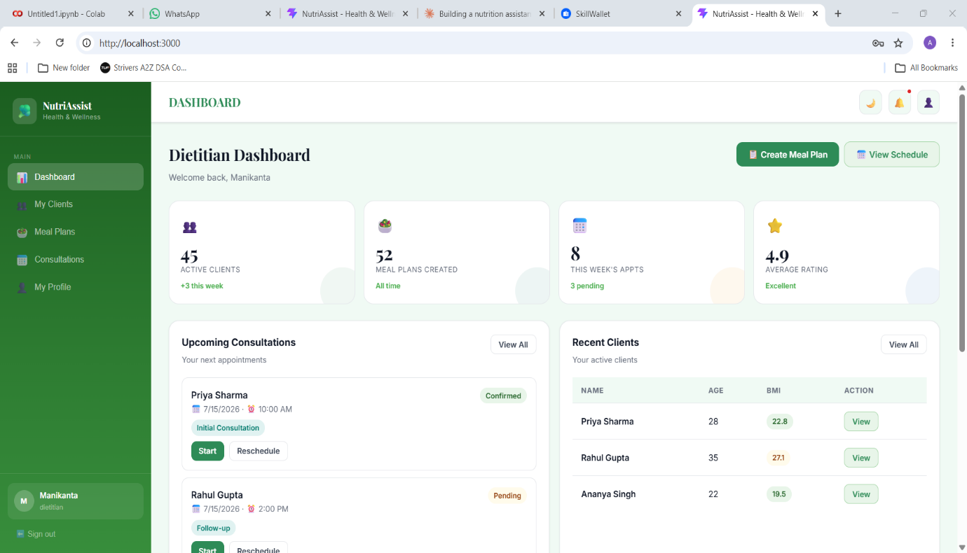

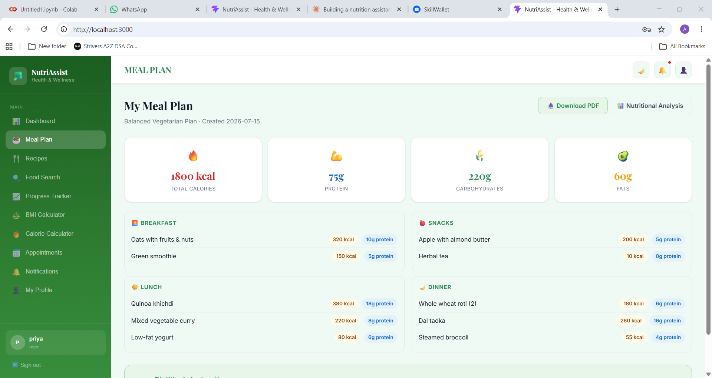
6. CONCLUSION
6.1 Conclusion
The Nutrition Assistant App successfully demonstrates how a full-stack MERN web application can be used to simplify personalized nutrition management for both individuals and dietitians. By combining React.js, Node.js, Express.js, and MongoDB within a clean, modular structure, the project delivers a functional dashboard that gives users immediate visibility into their nutrient intake and progress, along with complete CRUD management of client profiles and meal plans. The project further demonstrates good software engineering practice through the use of JWT-based role security, bcrypt password encryption, and Git for version control.
6.2 Future Scope
- Integrate with wearable devices and third-party health platforms for automatic activity and biometric data.
- Expand the food database with a more comprehensive, regularly updated nutrient dataset.
- Add AI-driven personalized meal and recipe recommendations based on user preferences and history.
- Introduce grocery list generation and integration with grocery delivery services.
- Add richer data visualization (trend lines, comparative charts) to the progress dashboard.
- Enable direct messaging between users and connected nutrition professionals.
- Containerize the application using Docker for more portable and consistent deployments.
- Add automated unit and integration tests to strengthen ongoing development.

